Chris Carrier WD 220

9/10/13 Chapter 2 Exercise’s

Exercise #2-1

<!DOCTYPE html PUBLIC "-//W3C//DTD XHTML 1.0 Strict//EN"

"http://www.w3.org/TR/xhtml1/DTD/xhtml1-strict.dtd">

<html xmlns="http://www.w3.org/1999/xhtml">

<head>

<title>Conditional Script</title>

<meta http-equiv="content-type" content="text/html; charset=iso-8859-1" />

</head>

<body>

<?php

$IntVariable = 75;

if($IntVariable > 100){

$Result = '$IntVariable is greater than 100';

}

else{

$Result = '$IntVariable is less than or equal to 100';

}

echo "<p>$Result</p>";

?>

</body>

</html>

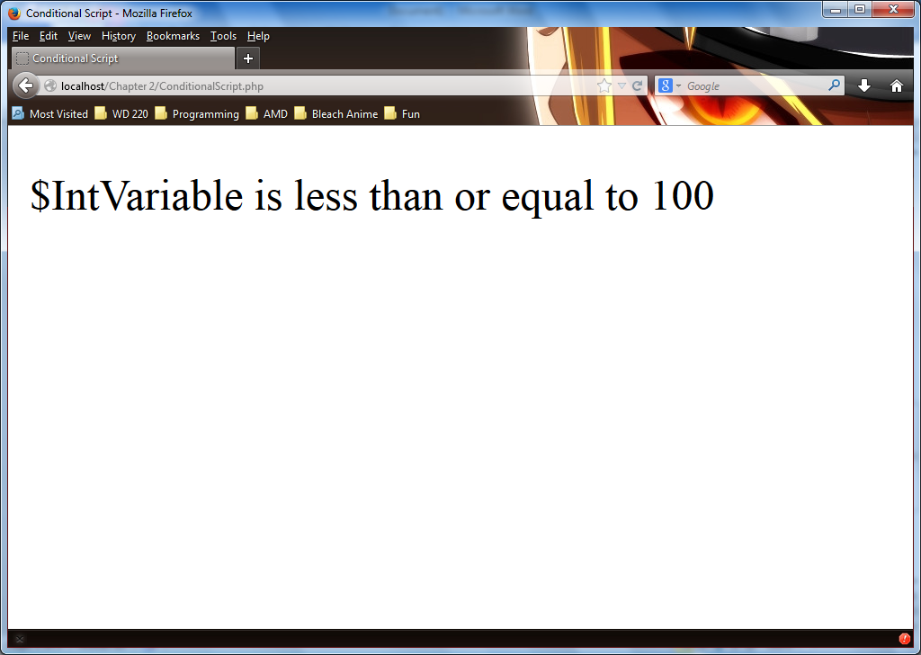

Exercise #2-2

<!DOCTYPE html PUBLIC "-//W3C//DTD XHTML 1.0 Strict//EN"

"http://www.w3.org/TR/xhtml1/DTD/xhtml1-strict.dtd">

<html xmlns="http://www.w3.org/1999/xhtml">

<head>

<title>Odd Numbers</title>

<meta http-equiv="content-type" content="text/html; charset=iso-8859-1" />

</head>

<body>

<?php

$Number = 1;

while($Number <= 100) {

$Result = $Number;

echo '<p>The value of $Number is: ', $Number, "!<br />";

$Number += 2;

}

?>

</body>

</html>

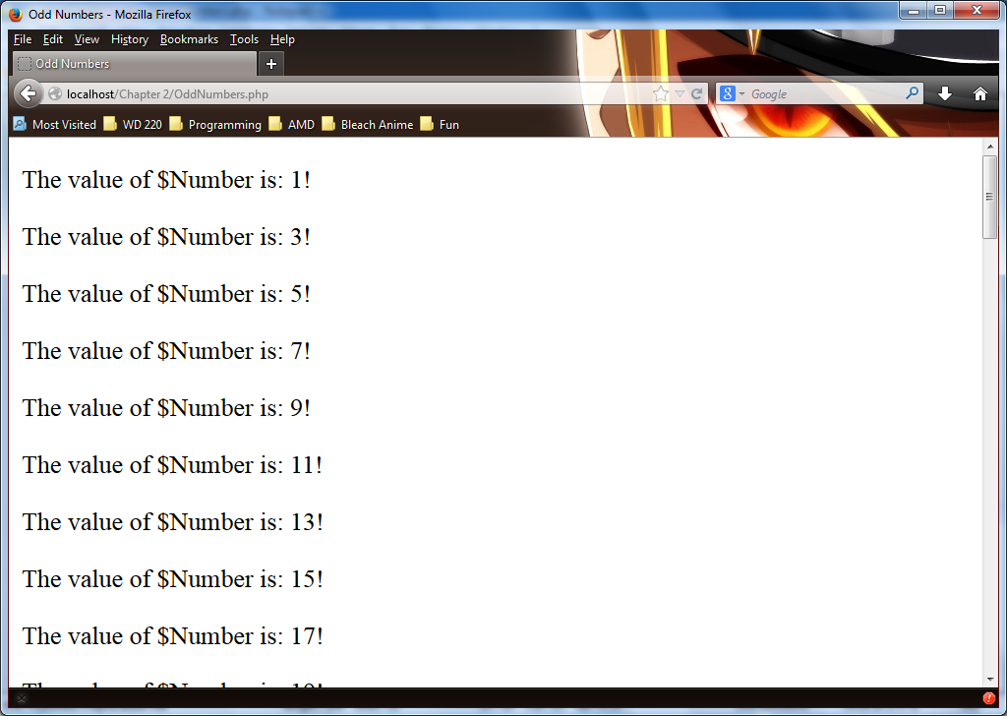

Exercise 2-5

Main page Code

<!DOCTYPE html PUBLIC "-//W3C//DTD XHTML 1.0 Strict//EN"

"http://www.w3.org/TR/xhtml1/DTD/xhtml1-strict.dtd">

<html xmlns="http://www.w3.org/1999/xhtml">

<head>

<title></title>

<meta http-equiv="content-type" content="text/html; charset=iso-8859-1" />

</head>

<body>

<?php

include("inc_header.php");

?>

<h2>Memorial Day Sales</h2>

<ul>

<li>Compaq Presario m2007us Notebook: <strong>$799.99</strong></li>

<li>Epson Stylus CX6600 Color All-In-One Printer, Print/ Copy/ Scan:

<strong>$699.99</strong></li>

<li>Proview Technology Inc. KDS K715s 17-inch LCD Monitor, Silver/ Black:

<strong>$199.99</strong></li>

<li>Hawking Technology Hi-Speed Wireless-G Cardbus Card: <strong>$9.99</strong></li>

</ul>

<?php

include("inc_footer.php");

?>

</body>

</html>

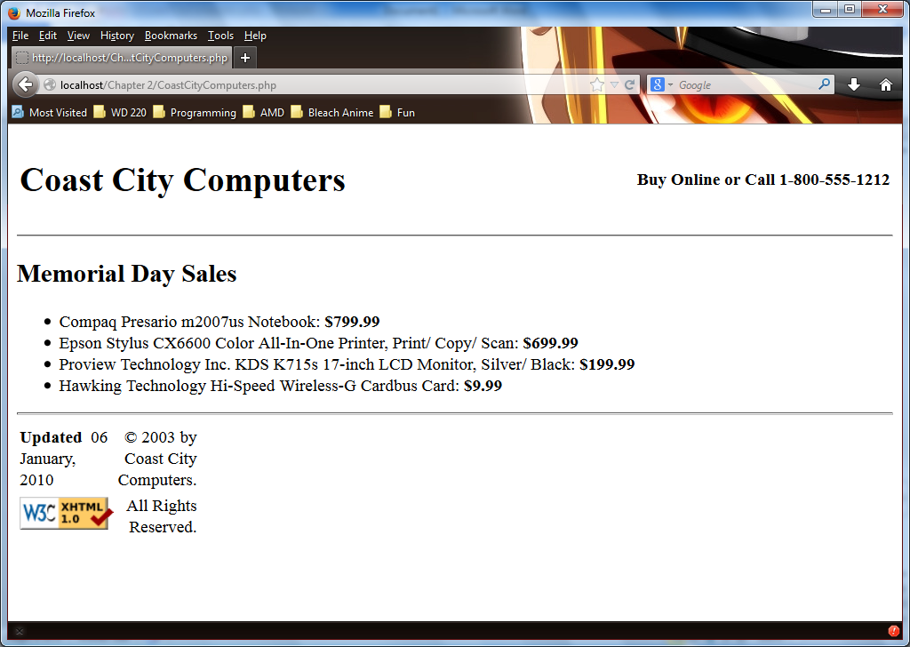

Header of Exercise 2-5

<!DOCTYPE html PUBLIC "-//W3C//DTD XHTML 1.0 Strict//EN"

"http://www.w3.org/TR/xhtml1/DTD/xhtml1-strict.dtd">

<html xmlns="http://www.w3.org/1999/xhtml">

<head>

<title>Default PHP Starter Page!</title>

<meta http-equiv="content-type" content="text/html; charset=iso-8859-1" />

</head>

<body>

<?php

?>

<table width="100%" style="border: 0">

<tr>

<td>

<h1>Coast City Computers</h1>

</td>

<td style="text-align: right">

<strong>Buy Online or Call 1-800-555-1212</strong>

</td>

</tr>

</table>

<hr />

</body>

</html>

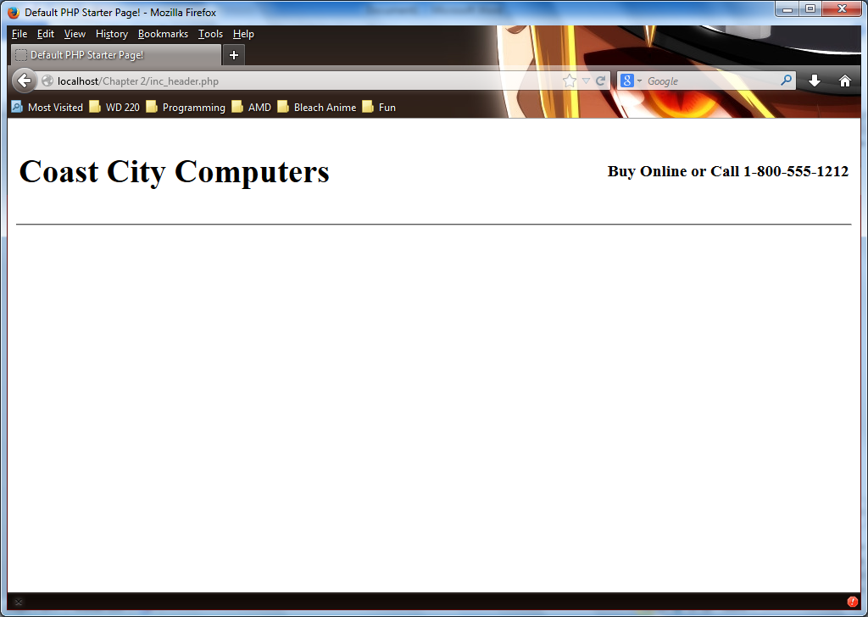

Footer of Exercise 2-5

<!DOCTYPE html PUBLIC "-//W3C//DTD XHTML 1.0 Strict//EN"

"http://www.w3.org/TR/xhtml1/DTD/xhtml1-strict.dtd">

<html xmlns="http://www.w3.org/1999/xhtml">

<head>

<title>Default PHP Starter Page!</title>

<meta http-equiv="content-type" content="text/html; charset=iso-8859-1" />

</head>

<body>

<?php

?>

<hr />

<table width="100" style="border: 0">

<tr>

<td><strong>Updated</strong>&nbsp; 06 January, 2010</td>

<td style="text-align: right">&copy; 2003 by Coast City Computers.</td>

</tr>

<tr>

<td>

<a href="http://validator.w3.org/check/referer">

<img src="http://www.w3.org/Icons/valid-xhtml10" alt="Valid XHTML 1.0!" height="31"width="88" /></a>

</td>

<td style="text-align: right; vertical-align: top">All Rights Reserved.</td>

</tr>

</table>

</body>

</html>

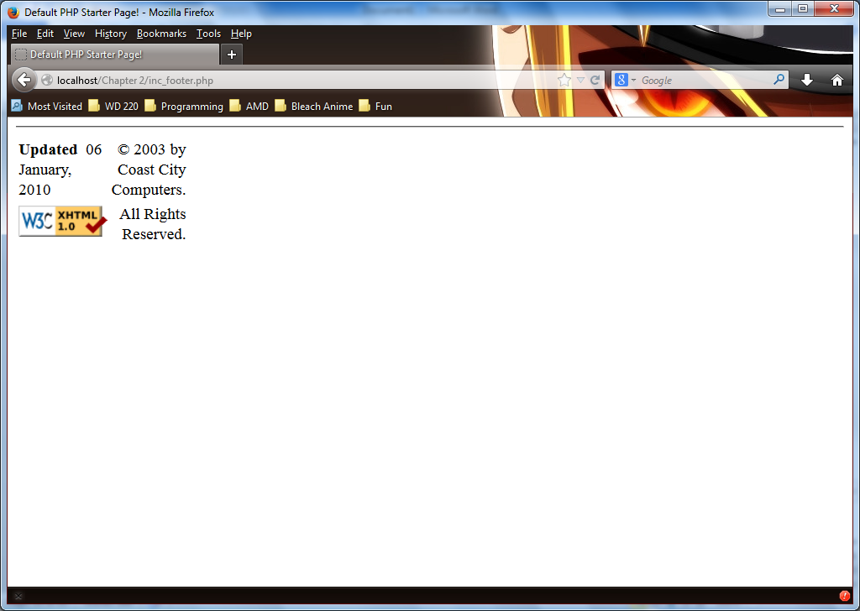

Exercise 2-6

<!DOCTYPE html PUBLIC "-//W3C//DTD XHTML 1.0 Strict//EN"

"http://www.w3.org/TR/xhtml1/DTD/xhtml1-strict.dtd">

<html xmlns="http://www.w3.org/1999/xhtml">

<head>

<title>Temperature Conversion</title>

<meta http-equiv="content-type" content="text/html; charset=iso-8859-1" />

</head>

<body>

<?php

$Fahrenheit = 0;

$Celsius = 0;

$Number = 1;

while($Fahrenheit <= 100){

$Celsius = (($Fahrenheit - 32) * (5/9));

$Fahrenheit = (($Celsius * (9/5)) + 32);

echo "<p>", $Number, ".) The converted temperature from Fahrenheit to Celsius is: ";

echo round($Celsius, 1), "<br />";

echo "The converted temperature from Celsius to Fahrenheit is: ",

$Fahrenheit, "<br />";

++$Number;

++$Fahrenheit;

}

?>

</body>

</html>

